How to start sub process

1. we can start the sub-process by using assertion if it is an tibco 6.7 or above 6.7 versions .if have a 6.3 version we can install maven plugin as use it into maven studio.
2. And anathor way is we can run the subprocess in process launcher while debugging.
3. Using the process launcher feature, you can see and test the subprocesses, which can accept the input. The input to the process instance is provided through the process launcher to test the subprocess individually.
4. You can use process launcher by running the application in the debug mode. That is navigate to Run > Debug Configurations, navigate to the Process Launcher tab, and select the subprocess to test.
5. In the Process Launcher tab, all the requests created for a subprocess are listed under the respective subprocesses. The invoke button (IMG_256) for the listed request messages is enabled only after initiating the process, which called the respective subprocess to be tested"

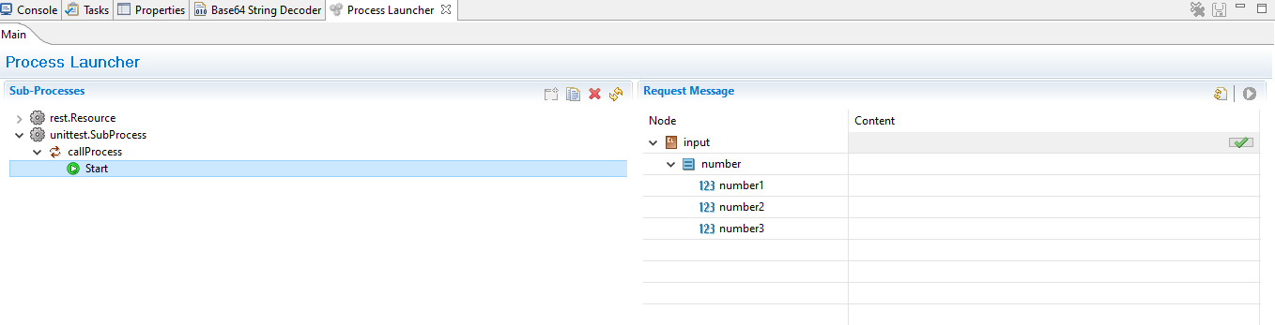

1. Give the values in the start activity and and click on check right symbole in beside of the input then we can see the out put of the subprocess.